CSMA/CA (Carrier Sense Multiple Access with Collision Avoidance) - IEEE 802.11

1. Introduction
CSMA/CA (Collision Avoidance) is the medium access control protocol used in IEEE 802.11 (Wi-Fi). It is conceptually similar to Ethernet’s CSMA/CD, but differs because wireless stations cannot reliably detect collisions. Instead of detecting collisions, CSMA/CA tries to avoid them using random backoff, acknowledgements, and control frames.

2. Distributed Coordination Function (DCF)
- DCF is the fundamental access method in IEEE 802.11.
- Each station operates independently, sensing the channel before transmitting.
- Steps:
1. A station waits for the channel to be idle for a time interval called DIFS (Distributed InterFrame Space).
2. It chooses a random backoff counter ( e.g., 0–15 slots).
3. The counter decreases only when the channel is idle.
4. Transmission begins when the counter reaches zero.
- If no ACK is received, the station doubles its contention window (binary exponential backoff).

3. Point Coordination Function (PCF)
- An optional centralized mode where the Access Point (AP) controls medium access.
- AP polls stations for transmission, reducing collisions.
- Rarely used in practice because nearby networks cannot be controlled by the AP.

4. Hidden and Exposed Terminal Problems
a) Hidden Terminal Problem:
- Occurs when a station cannot sense another ongoing transmission due to being out of range.
- Example: C transmits to B, A cannot sense C, and wrongly starts transmitting to B, causing collision.
b) Exposed Terminal Problem:
- Occurs when a station defers unnecessarily due to sensing another transmission that would not cause interference.
- Example: A transmits to D, B wants to send to C but refrains because it senses A’s transmission.

5. Carrier Sensing Mechanisms
- Physical Sensing: Station senses the channel for ongoing signals.
- Virtual Sensing: Uses the Network Allocation Vector (NAV) field in frames to indicate channel usage duration.
- NAV helps prevent hidden terminal collisions by logically reserving the channel.
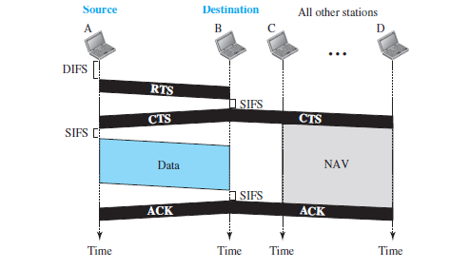
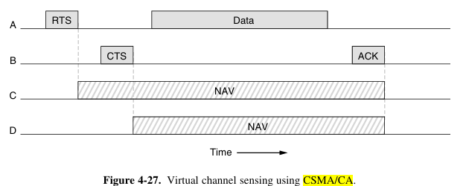

6. RTS/CTS Mechanism
- Request to Send (RTS) and Clear to Send (CTS) control frames reduce hidden terminal collisions.
- Sequence:
1. Sender sends RTS to receiver.
2. Receiver replies with CTS.
3. Sender transmits data and waits for ACK.
- Stations hearing RTS or CTS update NAV to remain silent.
- Effective mainly for large frames, but rarely used in practice due to overhead.

7. Reliability Enhancements
- Wireless channels are noisy and error-prone.
- Mechanisms include:
• Shorter frames or fragmentation (reduces error probability).
• Stop-and-wait ARQ for fragment transmission.
• Rate adaptation: Stations lower data rate when errors are high, and increase when conditions improve.

8. Power Management
- Battery saving is crucial for mobile devices.
- Mechanisms:
• Beacons: AP periodically advertises presence and buffered traffic.
• Power Save Mode: Clients doze and wake up for beacons.
• APSD (Automatic Power Save Delivery): Frames buffered by AP are delivered after a client transmission.
- Reduces power consumption in applications like VoIP.

9. Quality of Service (QoS) – IEEE 802.11e
- QoS is needed for real-time applications like VoIP.
- Mechanisms:
• Interframe Spacing (IFS):
- SIFS (Short IFS): Highest priority (ACKs, CTS, next fragment).
- DIFS: Used for normal data.
- AIFS (Arbitration IFS): Different values for different traffic priorities.
- EIFS: Used after receiving a bad frame.
• Transmission Opportunity (TXOP):
- Each station gets a time slot to transmit multiple frames.
- Prevents slower stations from unfairly reducing overall throughput (solves rate anomaly).

10. Conclusion
CSMA/CA is the backbone of IEEE 802.11 MAC layer. It avoids collisions using random backoff, ACK-based reliability, NAV-based virtual sensing, and optional RTS/CTS control. Enhancements such as power management and QoS (802.11e) make it efficient for modern wireless applications. Unlike CSMA/CD, which detects collisions, CSMA/CA prevents them proactively.

